ADMIN
- 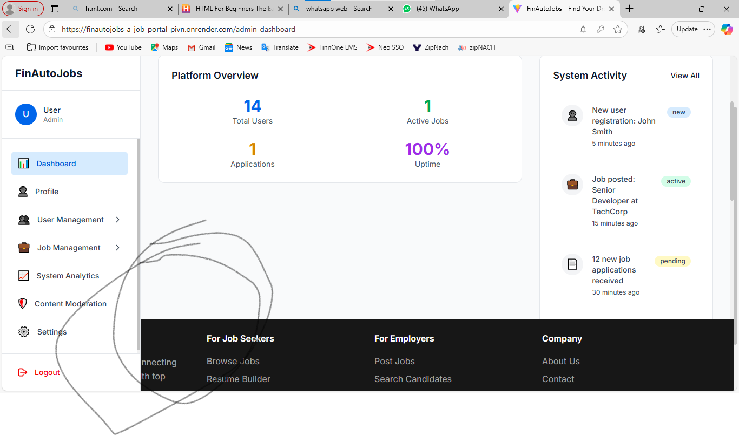
- We don’t need black portion on every pages
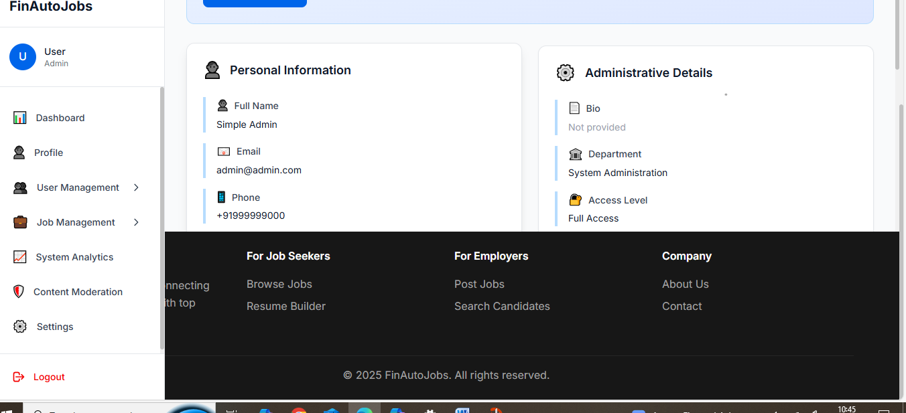
- can we make actions as list
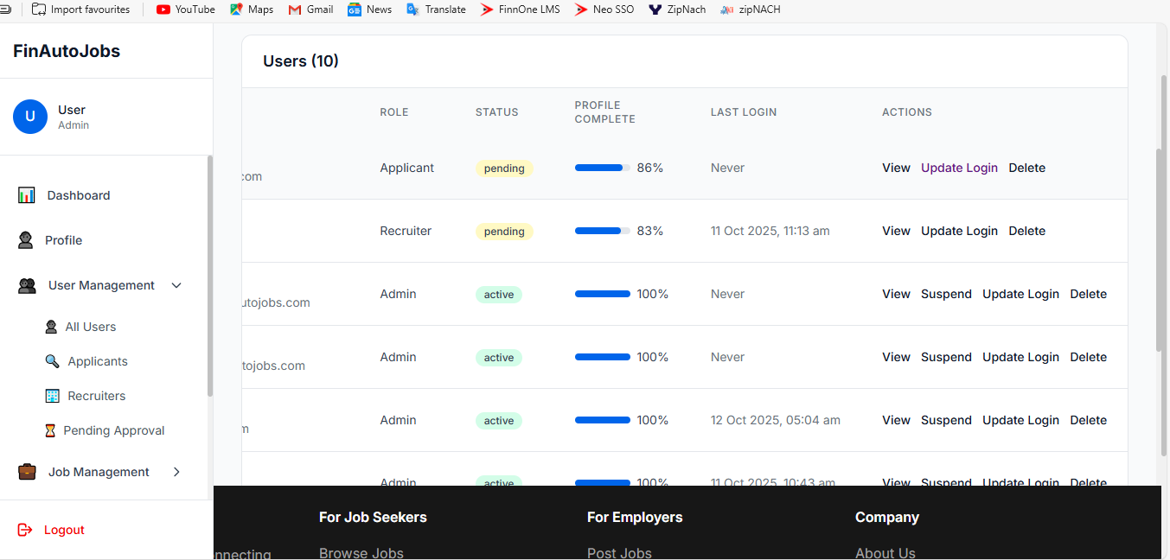
- applicant ,recureter panding approval not working in user management
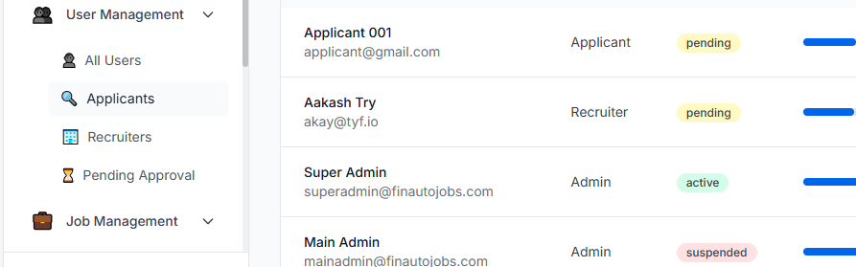
- ADD USER IS NOT WORKING AT ADMIN SIDE

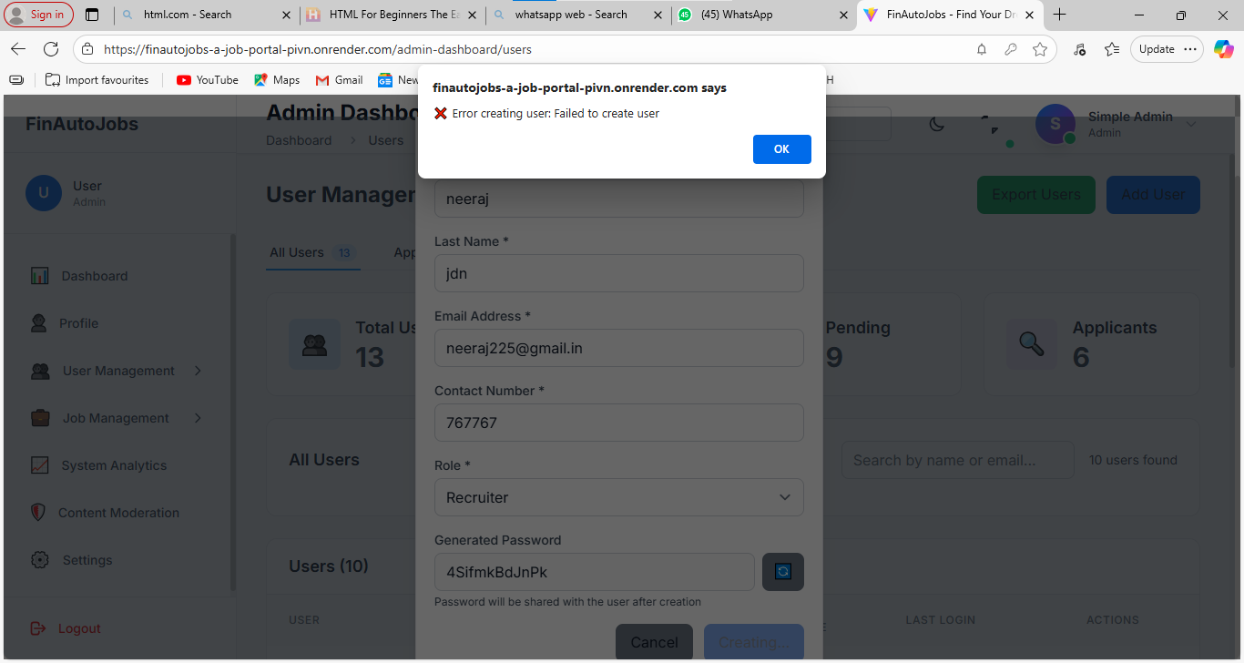

APPLICANT

- RAGISTRATION UI NEED TO BE FIXED 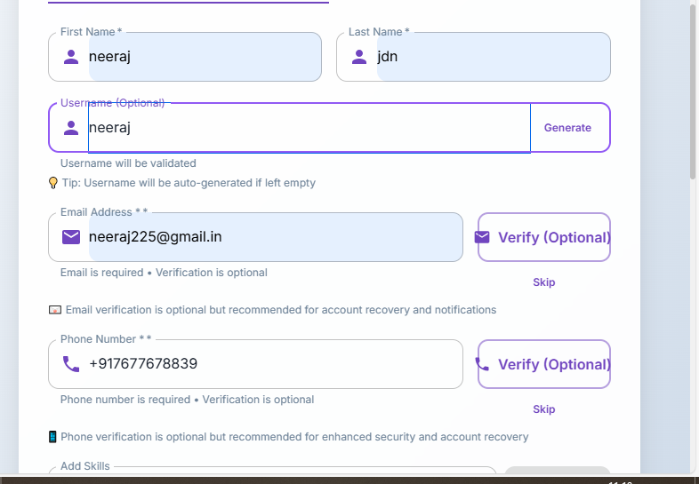
- SEARCH IS NOT WORKING
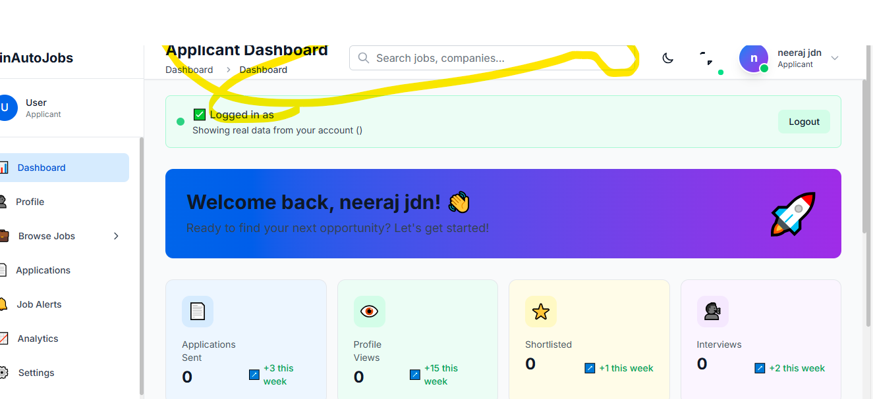
- How to add job in fev
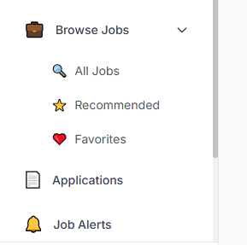
- Application count not reflating at dashbord of applicant
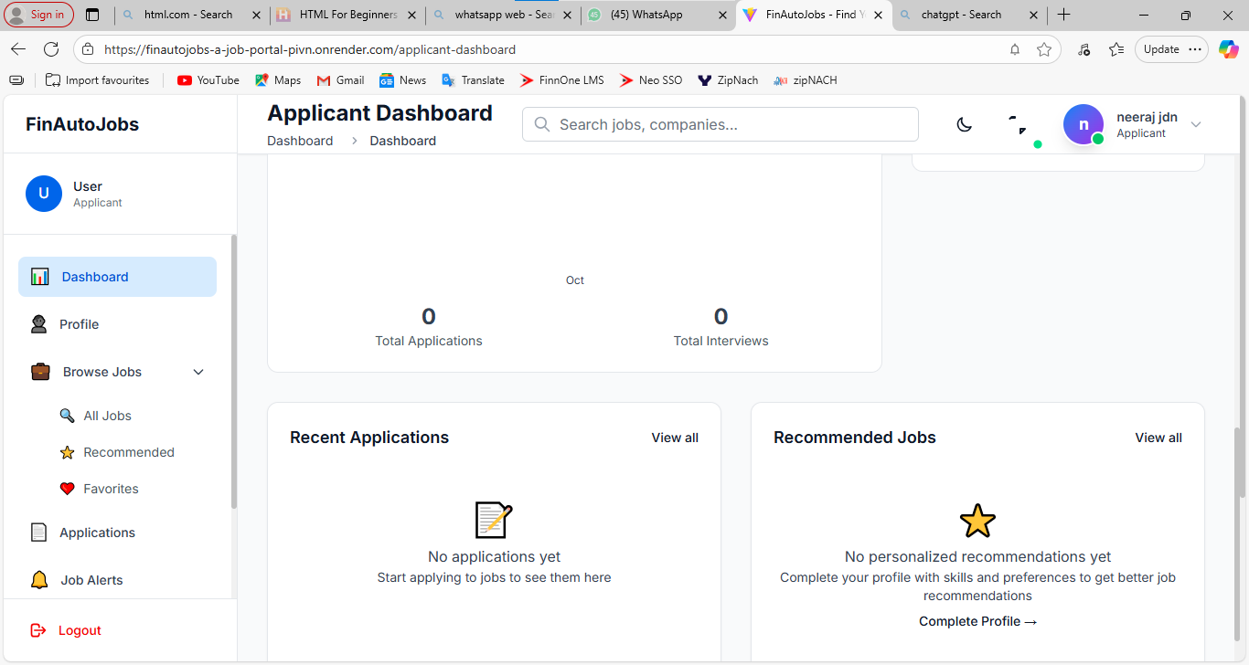

Recurter
1) search is not working
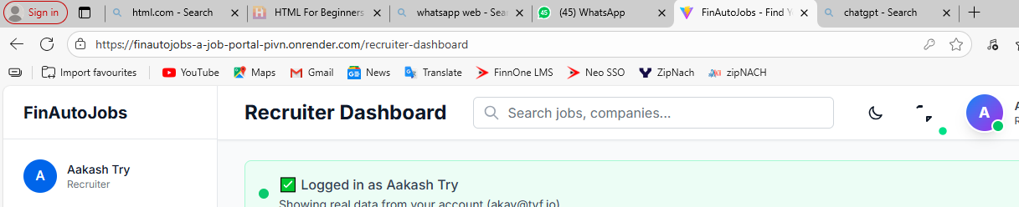
2)cant scadual interviwe
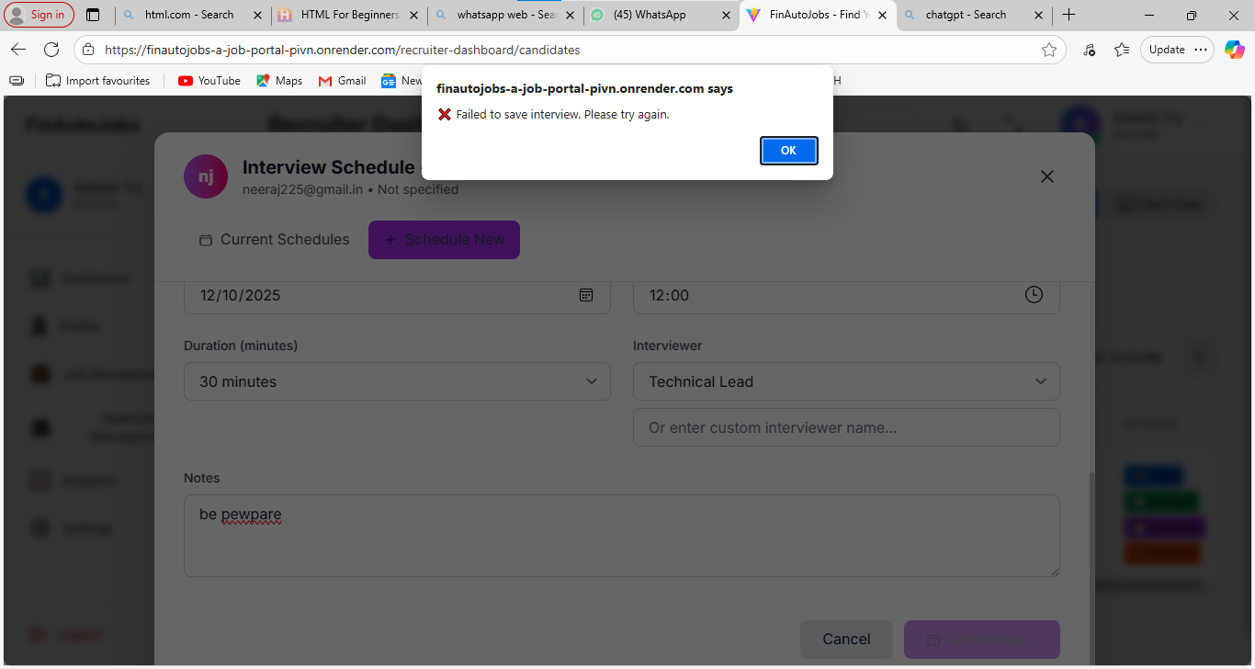

Super admin
1)cant able to add admin
or delete
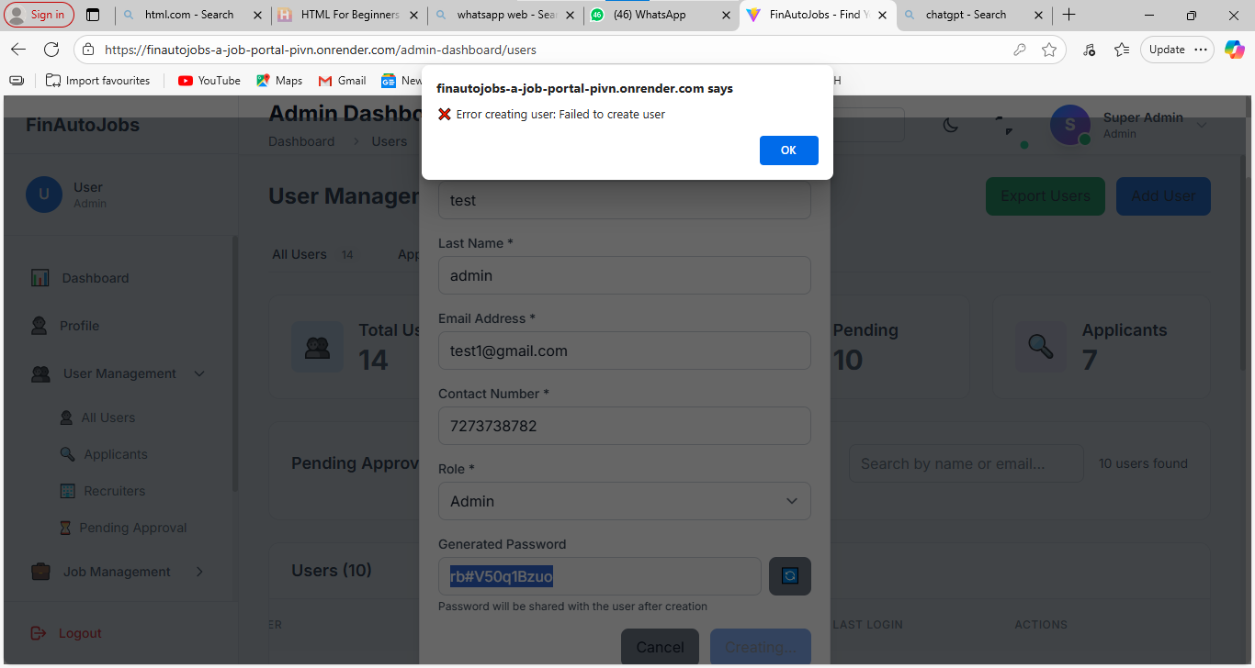
all else seems working
can add admin list in user management

